Checklist for Module 05
Retain Talent Management 4.0

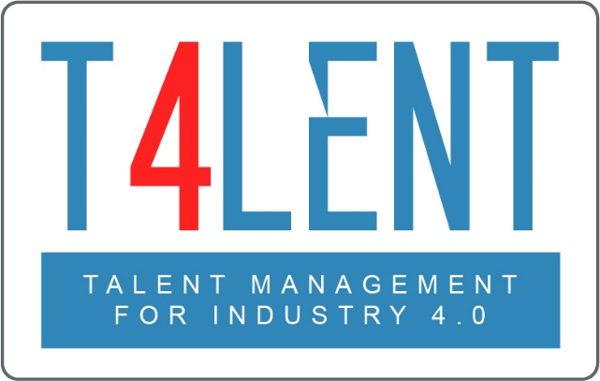
–

Project Name: Bridging the gap between VET and business: Modern talent management and analytics 4.0 for SMEs in Europe
Project Acronym: Talent 4.0
Project Number: 2018-1-AT01-KA202-039242

Checklist for Module 05- Retain to Talent Management 4.0

- Comprehend what Retention concept is in an organization

- Understand its importance in terns of Org. Culture, Career Development and Employee Alignment objectives.

- Grasp the fact that employee retention is an essential pillar of Talent Management

- Realize the benefits of Employee Retention for SMEs/Organization.

- Understand the Organization Culture

- Analyse the different forms of Employee Alignment with the Organization objectives.

- Identify steps in designing an Organization Culture.

- Work in groups to develop an employee Career Development Plan.

- Become aware of the steps that need to be taken in order to implement an effective Career Development Plan.

- Comprehend the important and role of executives to align organization objectives with employee career plan.

- Familiarize yourself with effective tools and methods to successfully pursue a Strong Organization Culture, Career Development and Employee Alignment.

- Work in groups and explore questions on talent retention found in the worksheets of the module.

- Develop a mock Career development plan for yourself or an employee using the template provided to better understand the process and its different parameters

- Use the templates provided by the Module to plan the retention strategy for your employees

To find out more go to our project website
t4lent.eu

or our facebook page
@t4lent.eu

