Checklist for Module 04
How to motivate your Employees

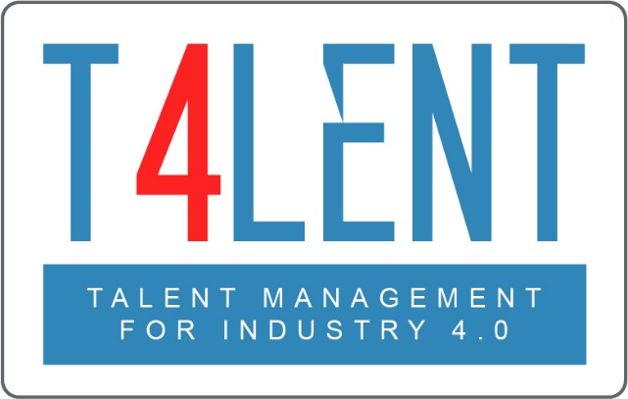
–

Project Name: Bridging the gap between VET and business: Modern talent management and analytics 4.0 for SMEs in Europe
Project Acronym: Talent 4.0
Project Number: 2018-1-AT01-KA202-039242

Checklist for Module 04- How to motivate your Employees

- Understand the theory about individuals´s motivation
- Differences between intrinsic and extrinsic motivation
- General methods and tips about “How to motivate your Employees”
- Knowledge about “How to measure Employee Motivation”
- Learn about “How to improve Employee Motivation”
- Understands expectations , goals and motivation
of business Generation Z (Talent 4.0)
- Motivating Employees with internal feedback and communication
- Classify the basic needs of employees
- Indicators to measure employee motivation
- Best practice “How to create a positive company culture”
- Work group discussion “What motivates you to go to work?“
- Familiarize yourself with effective tools and methods to successfully improve employee motivation (Toolbox Talent 4.0)
- Work in groups and explore questions on talent development found in the worksheets of the module

To find out more go to our project website
t4lent.eu

or our facebook page
@t4lent.eu

