Checklist for Module 03
Develop – Identify and Build-Up the talents of your team

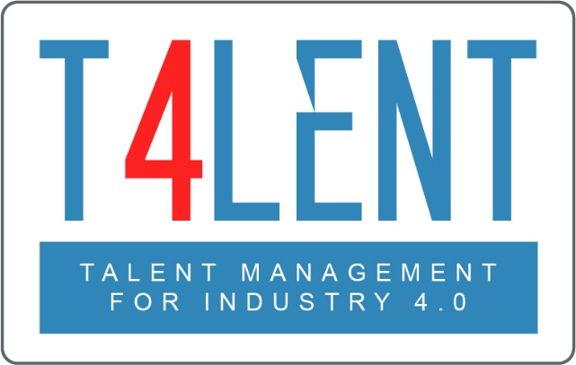
–

Project Name: Bridging the gap between VET and business: Modern talent management and analytics 4.0 for SMEs in Europe
Project Acronym: Talent 4.0
Project Number: 2018-1-AT01-KA202-039242

Checklist for Module 03- Employee Development

- Understand what employee development is
- Comprehend its importance for an SME/Organization
- Grasp the fact that employee development is an essential pillar of Talent Management
- Distinguish between employee development and training
- Realize the benefits of Employee Development for SMEs/Organizations
- Understand the employee development plan process
- Analyze the different forms of employee development plan
- Identify steps in designing an employee development-growth plan
- Realize that there is no one-size-fits-all solution in the learning and development process
- Work in groups to develop an employee plan for the case studies provided by the Module in Unit 2
- Become aware of the steps that need to be taken in order to implement an effective development plan
- Comprehend the important and role of executives and internal communication in the employee development process
- Familiarize yourself with effective tools and methods to successfully pursue employee development
- Work in groups and explore questions on talent development found in the worksheets of the module
- Develop a mock Personal development plan for yourself or an employee using the template provided to better understand the process and its different parameters
- Use the templates provided by the Module to develop development plans for your employees

To find out more go to our project website
t4lent.eu

or our facebook page
@t4lent.eu

