ASSESSMENT MODULE 01
Key questions for Learning Unit 01 - 03

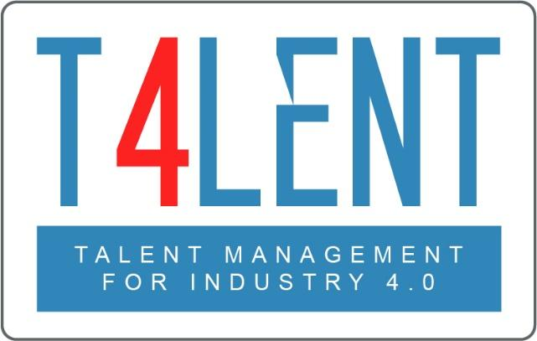
–

Project Name: Bridging the gap between VET and business: Modern talent management and analytics 4.0 for SMEs in Europe
Project Acronym: Talent 4.0
Project Number: 2018-1-AT01-KA202-039242

Assessment of Module 01: Check-in to Talent Management 4.0

Q01: Which statements are correct?
- The term talent can be universally defined
- Talent depends on the (business) context
- Talent can be naturally given
- Everybody has talents that can become important at some point
Comment: There is no universal definition of talent available, as talent is something very individual and context dependent.

Q02: Integrated or inclusive talent management aims to make best use of the talent(s) of each member of staff to deal with current and upcoming challenges of an organisation.
- True
- False

Q03: Which statement is not correct?
- Talent Management is affected by many factors like demographic, economic and climate change.
- Changes regarding digital technologies play a minor role for talent management
- Organisations and their people will require qualities like openness, willingness to learn and flexibility.
Comment: Digital technologies are changing our societies rapidly – they have effects on the way we live, we do business and we manage talent.

Q04: A creed should be a very detailed and long statement about a company’s vision, values and goals.
- True
- False
Correct Answer: A creed should be clear and simple. It consists of core principles, values and mutual expectations that guide the behaviour of an organisation and its people. It´s a very important mission statement that guides all talent management efforts.

Q05: Which statement is correct? Talent Management aims to…
- Build the capacity of an organisation to react adequately to changes
- to focus only on the most talented people
- find the right people and put them in the right positions
Comment: An integrated talent management system includes aims to capture and develop the talent of all employees. At the same time, critical roles receive a special focus to secure these positions sustainably.

Q06: A successful talent management strategy…?
- should be aligned with the business strategy
- address the company culture
- include all important HR practices

Q07: The talent dilemmas diagnostic tool addresses the top ten talent dilemmas that organisations should factor in, when building a talent management strategy. It helps an organisation to orientate and align its strategy so it fits an organisation.
- True
- False

Q08: Talent Segmentation…
- is a process of dividing talents in different groups, so they can be better taken care of.
- is the process of identifying the job roles that are critical to an organisations success.
- is a staff selection process that aims to identify positions that can be made redundant.

Q09: Which statement is not correct?
- A competency model helps an organisation to clearly describe skills, knowledge and behaviours that are critical to business success and effectiveness.
- Competencies usually include soft factors and skills that make a difference in getting tasks done successfully.
- A good competency model is something general that can be used in all different kinds of organisations and companies
Comment: A good competency model is tailored to the needs and circumstances of an organisation and represents a collection of behavioural descriptions considered to be critical to success.

Q10: What are the general types of competencies (as per the model of Erpenbeck & Rosestiel 2007)?
- Personal competencies
- Social and communicative competencies
- Action competencies
- Digital competencies
- Competencies in methods and subject matter expertise
Comment: Digital competencies would not be a separate type of competencies as it would fall into the category “competencies in methods and subject matter expertise”.

To find out more go to our project website
t4lent.eu

or our facebook page
@t4lent.eu

