Training Programme
Develop-Mock Template for a Personal Development Plan

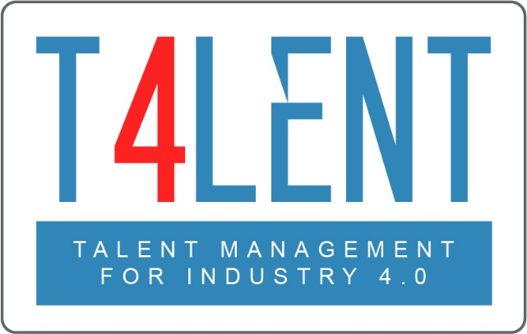
–

Project Name: Bridging the gap between VET and business: Modern talent management and analytics 4.0 for SMEs in Europe
Project Acronym: Talent 4.0
Project Number: 2018-1-AT01-KA202-039242
Personal Development Plan FORM
Employee Info
Name |  | Department
Position |  | Reviewer

MY CAREER  What are my aspirations for my career in the next 1-2 years and 3-5 years? |  | MY DEVELOPMENT  What are my strengths?
Record short-and longer-term career aspirations |  | Record top three strengths
Where was I at the start of this development journey? |  | What are my biggest development areas?
Record description of role history in the organisation |  | Record three largest development areas
Where am I now? |  | What actions do I need to take?
Record current role and achievements to date |  | Record actions to develop each area
What learning opportunities will I commit to taking after today? Use the 70:20:10 model to identify opportunities in each area.
Record experience-based activities | Record feedback-based activities |  | Record formal learning-based activities

Personal Development Plan EXAMPLE
Employee Info
Name | Julie Andrews | Department | Human Resources
Position | HR Assistant | Reviewer | Anna Karenina

MY CAREER  What are my aspirations for my career in the next 1-2 years and 3-5 years? |  | MY DEVELOPMENT  What are my strengths?
In the first 2 years of my career I would like to become a solid, dependable HR Assistant with limited need for supervision.  After 3-5 years I would like to development into an Assistant HR Manager |  | My top 3 strengths are:  - I quickly build good working relationships  - I am a quick learner  - I work well both independently and as part of a team
Where was I at the start of this development journey? |  | What are my biggest development areas?
I joined the organisation as a summer HR intern during my last year of university. Upon graduation from my BA in Human Resource Management I applied and got the role of HR Assistant. |  | - I’m not fully familiar with employment law  - I have no experience with budgets  - I am not very tech savvy
Where am I now? |  | What actions do I need to take?
I have met all my colleagues and took time to get to know them personally  I completed my induction programme  I have started reviewing some internal HR processes and making suggestions for simplification |  | 1. Study / attend course on employment law  2. Ask my manager if I can start being exposed to HR budgeting procedures  3. Use all the available IT systems available to me and ask for assistance where needed
What learning opportunities will I commit to taking after today? Use the 70:20:10 model to identify opportunities in each area.
- Use our HR Information system on a daily basis to learn its functionalities well  - Shadow my line manager to learn more about HR in practice  - Attend team and organisational meetings to better understand the business  - Use my Employment Law seminar notes to review and update our HR policies to be legally compliant | 1. Ask for anonymous feedback from colleagues whom I provide a service to  2. Ask feedback from my line manager during our regular 1-2-1s on my progress |  | - Attend the initial PeopleHR formal training to become our HR Information System’s Super User  - Use the PeopleHR online tutorials to further familiarize myself with the system  - Attend a seminar on Employment Law

To find out more go to our project website
t4lent.eu
or our Facebook page
@t4lent.eu

