Module 03: Employee development
Worksheet: Developing talent in SMEs – Questions for discussion

–
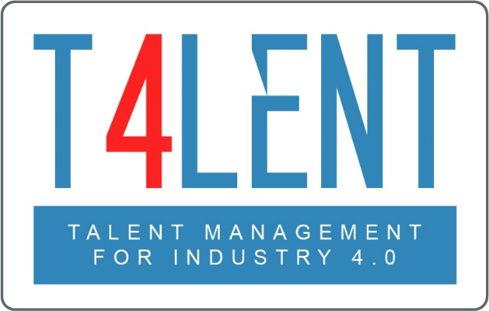

Project Name: Bridging the gap between VET and business: Modern talent management and analytics 4.0 for SMEs in Europe
Project Acronym: Talent 4.0
Project Number: 2018-1-AT01-KA202-039242

Instructions

Step 01 – Split into three teams

The learners should be split into three teams, each one given one of the questions provided below. The teams should invest 5 minutes to discuss the parameters of their question.

Step 02 – Presentation

The three teams should reconvene and each one of them should elect a representative to present the question they examined along with the list of measures and steps they are proposing. Individuals from all teams may make interventions for suggestions or ask questions in a bid to collectively find the best approach for them.

Step 03 – Discussion

Following the presentations, the group will be given the opportunity to discuss the process, any challenges they perceive in the process as well as things that they feel should be taken into consideration or approaches and steps they believe that can be useful from their personal or professional experience.

Question 1
Talent development can generate professional expectations. SMEs may not be in a position to provide opportunities for employees to meet those expectations. In which areas do you think this is most relevant and what would you recommend to an SME to do to find a solution?

Question 2
Usually talent development is associated with vertical evolution (bottom up career development). How can SMEs use horizontal and “specialist roles” development to their advantage?

Question 3
How long-term should SMEs realistically plan/look ahead when it comes to employee development? What sort of timeframe should the EDPs have?

To find out more go to our project website
t4lent.eu

or our Facebook page
@t4lent.eu

