Training Programme
Employee Development-Mock Template for a Performance Improvement Plan

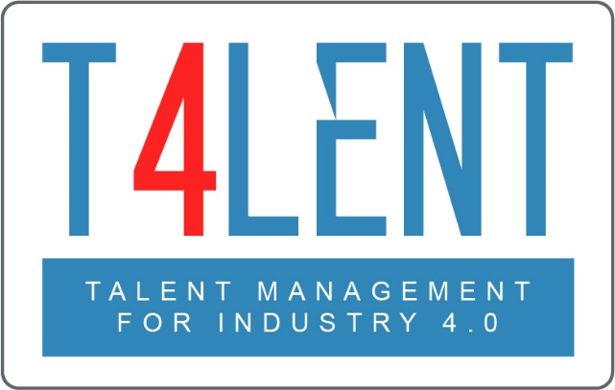

–

Project Name: Bridging the gap between VET and business: Modern talent management and analytics 4.0 for SMEs in Europe
Project Acronym: Talent 4.0
Project Number: 2018-1-AT01-KA202-039242
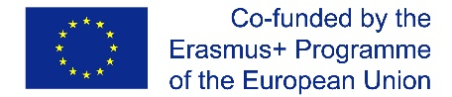
The European Commission support for the production of this publication does
not constitute an endorsement of the contents which reflects the views only
of the authors, and the Commission cannot be held responsible for any use which
may be made of the information contained therein.

Performance Improvement Plan FORM
Employee‘s Name: Manager’s Name:
Department:
Area to be improved | Action to improve performance | Targeted date for improvement | Expected results (e.g. measure of success)
Consequences of insufficient performance improvement:

Employee’s Signature……………………………….. Line Manager’s Signature .....................................
Date of discussion ………………………………........ Date of next discussion..........................................

EXAMPLE: Performance Improvement Plan
Employee‘s Name: Andrew Johnson (Marketing Assistant) Manager’s Name: Katya Kyrilov (Head of Marketing)
Area to be improved | Action to improve performance | Targeted date for improvement | Expected results (e.g. measure of success)
Punctuality and attendance | - Use more than 1 alarm to ensure you wake up in the mornings  - Arrange to wake up 20 minutes earlier and change your morning routine to be more efficient  - Use a calendar notification system for all appointments | 30th April | - Consistency in punctuality  - No incidence of lateness / no-show will be acceptable behaviour
Presentation skills | - Practice in front of line manager or another trusted colleague  - Receive feedback on slides and presentation style to improve prior to actual presentations | 31st March | Presentations to meet the topic objectives, measured via questionnaires at the end
Teamwork | - Offer assistance to colleagues proactively and follow-through  - Do not be offended by colleagues requesting your help | 30th April | Improved collaboration, measured via targeted feedback from colleagues
Consequences of insufficient performance improvement:

Failure to meet the expected results within the targeted date for improvement may lead to a non-satisfactory performance evaluation rating which will affect the salary increase/bonus decision.

Employee’s Signature……………………………….. Line Manager’s Signature .....................................
Date of discussion 01/02/2021 Date of next discussion 30/04/2021

To find out more go to our project website
t4lent.eu
or our Facebook page
@t4lent.eu

