Training Programme
Employee Development-Mock Template for a Professional Growth Plan

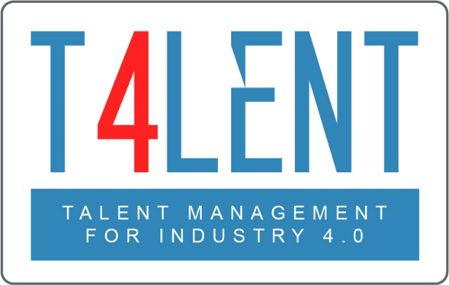

–

Project Name: Bridging the gap between VET and business: Modern talent management and analytics 4.0 for SMEs in Europe
Project Acronym: Talent 4.0
Project Number: 2018-1-AT01-KA202-039242
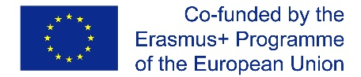
The European Commission support for the production of this publication does
not constitute an endorsement of the contents which reflects the views only
of the authors, and the Commission cannot be held responsible for any use which
may be made of the information contained therein.

Professional Growth PLAN FORM
Employee‘s Name: Manager’s Name:
Department:
Performance Dimension | Goals | Support - Action Required | Barriers & Steps to Overcome them | Expected results (e.g. measure of success) | Notes
OPERATIONAL

LEADERSHIP

MANAGEMENT

RELATIONSHIP

INNOVATION

Employee’s Signature……………………………….. Line Manager’s Signature .....................................

Date of discussion ………………………………........ Date of next discussion..........................................
EXAMPLE: Professional Growth PLAN FORM
Employee‘s Name: Andrew Johnson (Marketing Assistant) Manager’s Name: Katya Kyrilov (Head of Marketing)
Performance Dimension | Goals | Support - Action Required | Barriers & Steps to Overcome them | Expected results (e.g. measure of success) | Notes
OPERATIONAL | Take a Multimedia online course | Organisation to approve the cost of the course | Find a course that is not expensive but of good quality that will easily be approved | Course to be completed by the end of October and course work examples to be used for our Twitter, LinkedIn & Facebook business pages by the end of November | Attending such a course will help me improve my knowledge on social media campaigns
LEADERSHIP | Lead a project team | Coaching and mentoring from line manager | It is considered too early to be given a project team this year. Will need to find other ways to develop leadership skills | Convincing others to my point of view and getting them to work with me on certain projects or tasks, following my vision and direction. | My longterm goal is to develop into a leadership role within the organisation. Having the opportunity to lead a project team will help me develop leadership skills
MANAGEMENT | Manage a project from start to finish, including proposal writing and budgeting | Regular feedback from my manager to ensure I’m managing the project correctly | Finding a project that is relevant but not from a very expensive client account for a junior employee may take time | Once the appropriate project is found it will need to be completed in time, within budget, having delivered a quality product for the client. | My line manager will search for an appropriate project to assign this year.
RELATIONSHIP | Work closely with XYZ stakeholder on the ABC campaign to build a long-term relationship and further grow my network
INNOVATION | Come up with a unique idea for Brand A’s summer marketing campaign that will be put forward to the client as part of their 3 options presented from us | I may need help from colleagues to brainstorm ideas | I will need to work on at least 3 unique ideas of my own to expect to get 1 of them put forward | Find

Employee’s Signature……………………………….. Line Manager’s Signature .....................................
Date of discussion 15/6/2020 Date of next discussion 15/6/2021

To find out more go to our project website
t4lent.eu
or our Facebook page
@t4lent.eu

