Module 01: Check-in to Talent management 4.0
Worksheet 01.2: Creating your creed

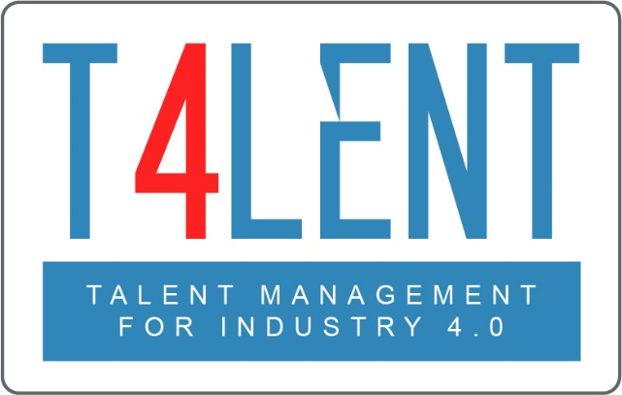

Project Name: Bridging the gap between VET and business: Modern talent management and analytics 4.0 for SMEs in Europe
Project Acronym: Talent 4.0
Project Number: 2018-1-AT01-KA202-039242

Step 01 – Why are you doing what do you are doing? - Brainstorm values and guiding principles

Perform a quick brainstorming by answering the following question for each of the groups mentioned below.
What are your general guiding values and principles and the ones towards customers, employees and society.
General:
- Value 01

- …

Customers:
- Value 01

- …

Employees:
- Value 01

- …

Society
- Value 01

- …

Step 02: Creating version one of your creed

Now it´s time to condense your ideas, values and guiding principles and formulate the first draft of your creed. It will guide all your talent management efforts that follow.
Write down your creed. Try to formulate short and precise sentences. The order is not yet so important. You can change it later on. Focus on what is important for your business – what guides you!
Our values and principles

We…

To find out more go to our project website
t4lent.eu

or our facebook page
@t4lent.eu

