Module 01: Check-in to Talent management 4.0
Worksheet 01.1 - First steps to define talent

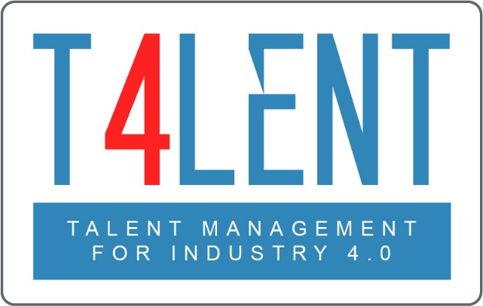
–

Project Name: Bridging the gap between VET and business: Modern talent management and analytics 4.0 for SMEs in Europe
Project Acronym: Talent 4.0
Project Number: 2018-1-AT01-KA202-039242

Step 01 - Braindump

We start with a simple method that is used at the very start of every creative process, a braindump.
Perform a 5 minutes brainstorming regarding the term “Talent”. Write down everything that comes to mind in form of a list below.
- Thought 01
- …

Step 02: Structured brainstorming

Now the time has come to guide your creative potential in a more systematic way. Follow each step as described below. This exercise should not take longer than 10-15 minutes
- Think of your company and your staff. What are the key features of a good member of staff? This can be a lot of things (social skills, specific expertise, management skills, etc) | - If you think of high performing members of staff. What makes them outstanding? How do they differ from a “good” colleague? List their features/differences below.
- Feature 01  - Feature 02 | - Feature 01  - Feature 02

To find out more go to our project website
t4lent.eu

or our facebook page
@t4lent.eu

